***Database Systems (Assignment) Lab 11***

Name = Poorab Gangwani

Class = 4B1

Roll-Number = CS191092

1. Create a BEFORE DELETE trigger that maintains a log of the username of the user performing the deletion, the ID and name of the employee being deleted, and the timestamp of when the action is performed every time an employee is removed from the database.

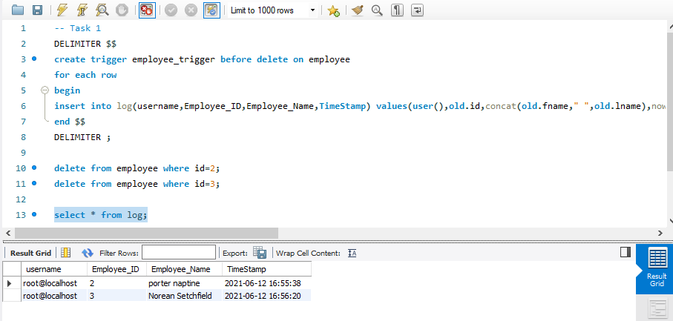

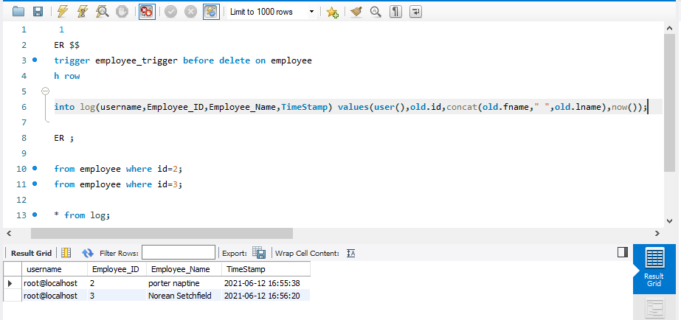

1. Write a query that displays the employee names and their designations if they have been assigned a designation or “No designation yet” if they have not yet been assigned a designation. Label appropriately

